e-GOS Report Award Guide

Once an award decision has been made, you must report the award in e-GOS. The steps below outline the process for reporting an award.

- In your web browser, go to https://cio.egos.nih.gov/#login and enter your username and password.

- Select the order from your Orders list.

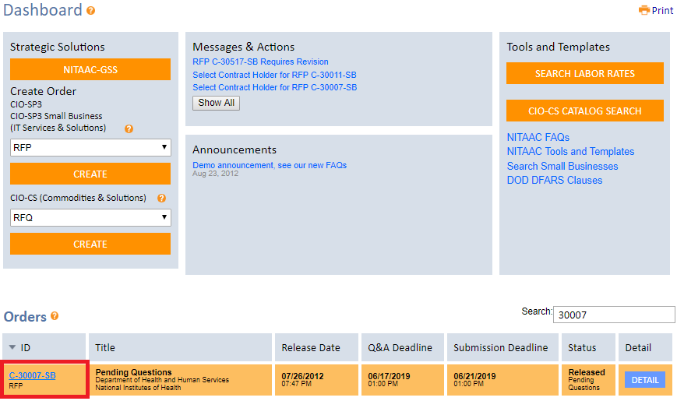

- Once you have selected the order, you will land on an order summary page. From here, click the “Compete” tab.

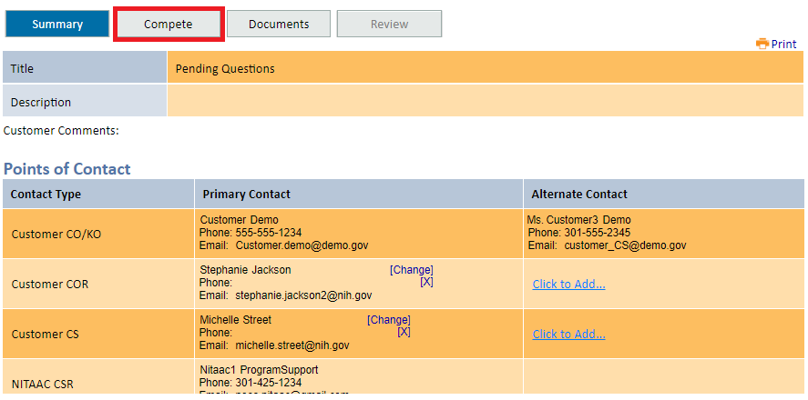

- Select the “Report Award” subtab, then check the box next to the offeror(s) you wish to award to and enter the award date.

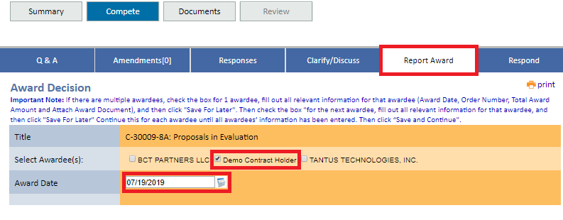

- Email notices are sent to unsuccessful offerors by default. If you do not wish for this notice to be sent, uncheck the “Unsuccessful Offerors” box.

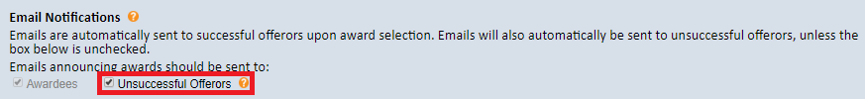

- Scroll to the bottom of the page, enter the order number and total award amount, then upload the award document and click “Attach.”

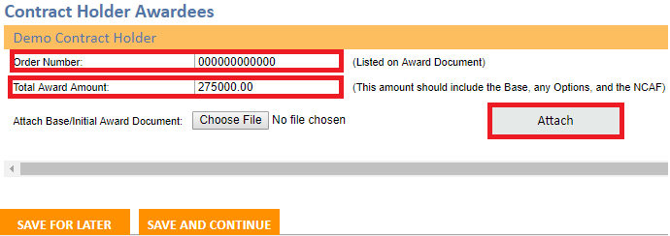

- Click “Add Base” then enter the award period information and total award amount in the box that populates. Click “Add.”

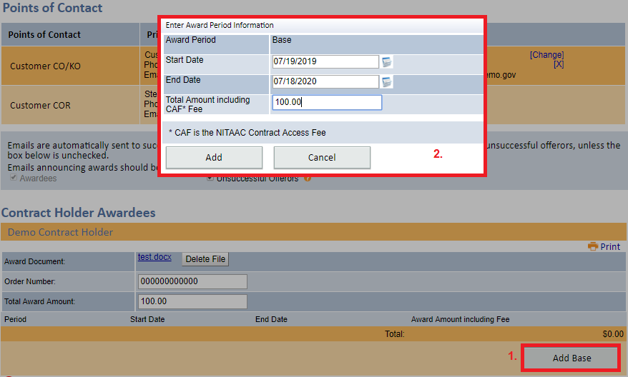

- Click “Add Option” to add any option years then click “Save and Continue.”

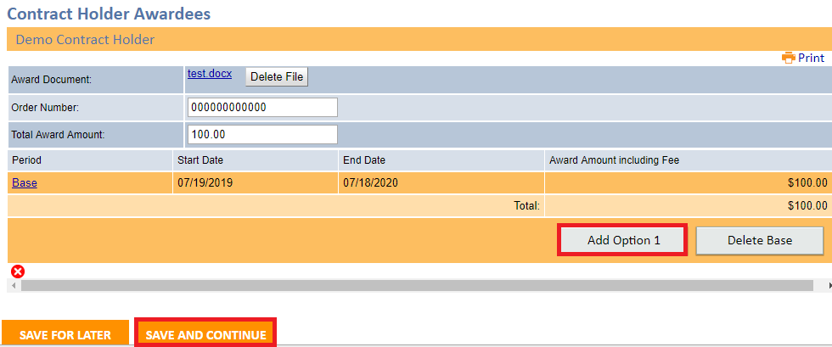

- Review information to ensure it is correct then click “Submit Award.”

