e-GOS Responses Guide

- In your web browser, go to https://cio.egos.nih.gov/#login and enter your username and password.

- Select the order from your Orders list.

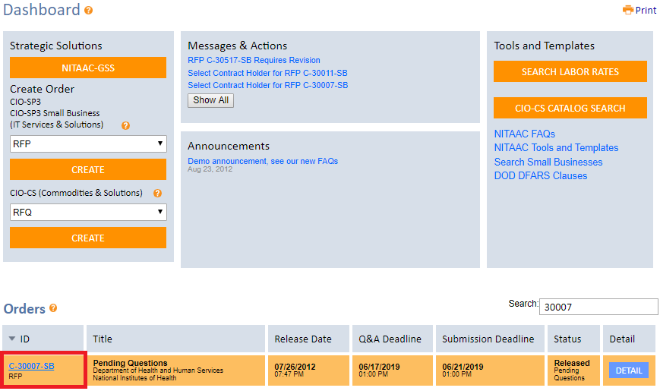

- Once you have selected the order, you will land on an order summary page. From here, click the “Compete” tab.

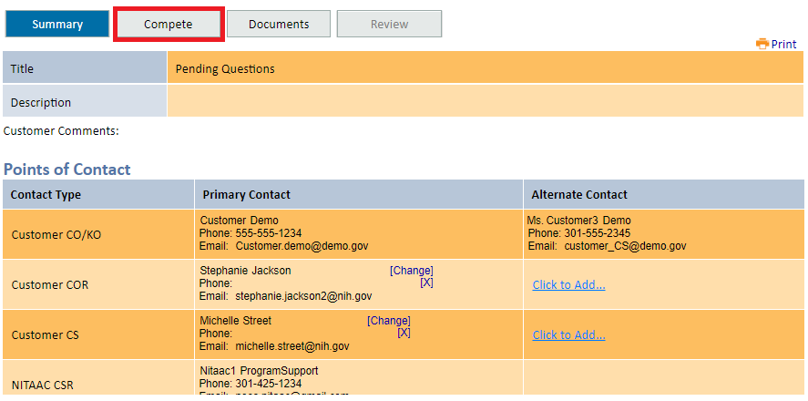

- Select the “Responses” subtab and you will see a page with a set of expandable lists. Click the plus icon to expand the “Responses” list and view contract holder proposal documents. You can also view a list of responses in progress, no bids, and contract holders who have not yet submitted by expanding the other lists.

