NITAAC Small Business Contract Holder Search

The NITAAC website provides a tool for agencies to search for small business and set-aside categories. To begin your search, follow these simple steps:

- In your web browser, go to www.nitaac.nih.gov

- Mouse over the “Services” tab, then click the “Contract Holders” link under CIO-SP3 Small Business.

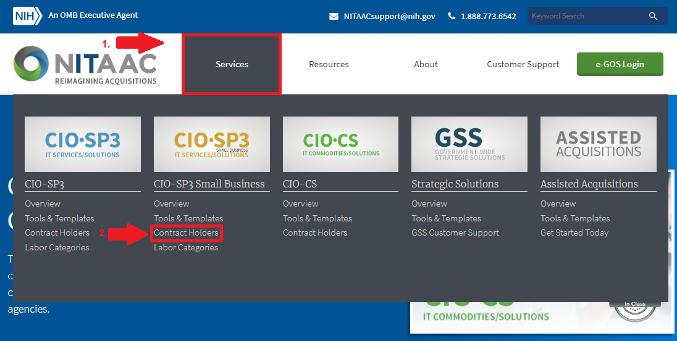

- The next screen will display a list of all contract holders under the CIO-SP3 Small Business GWAC.

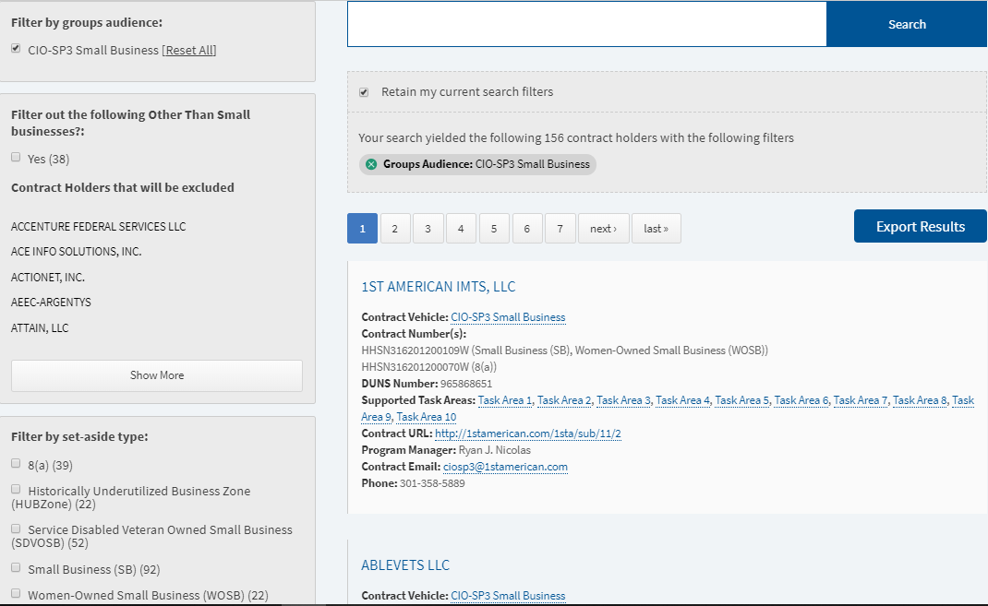

- You are able to filter the list by task areas and socio-economic category. You are also able to filter out other than small businesses (OTSB). To filter OTSBs simply check the box on the left side of the screen.

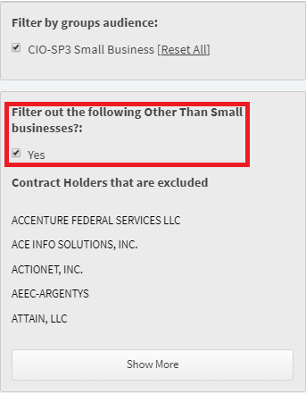

- To filter by socio-economic category simply select the category you need from the list on the left side of the screen.

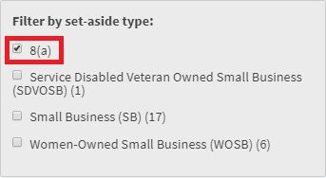

- To filter by task area check the boxes beside the task areas you would like to view.

