Environmental Protection Agency

Clean Air Markets Division of the Office of Air and Radiation/Office of Atmospheric Programs
Statement of Objectives
for the
CAMD Business Suite

Background
The Clean Air Markets Division (CAMD) of the Office of Air and Radiation/Office of Atmospheric Programs administers the Clean Air Allowance Trading Programs, including the Acid Rain Program (ARP), Cross-State Air Pollution Rule (CSAPR), and other related programs. These programs are designed to reduce stationary source pollutant emissions that can have harmful effects on human health and the environment. CAMD also supports the implementation of the Mercury and Air Toxics Standards (MATS) Rule, Greenhouse Gas Reporting Rule, and other state and federal emission reporting programs.
The CAMD programs are authorized by statute and regulation, including Title IV of the Clean Air Act and the following sections of the Code of Federal Regulations:
- Acid Rain Permits Regulation – Part 72 Sections 72.1 to 72.96
- Sulfur Dioxide Allowance System – Part 73 Sections 73.1 to 73.90
- Sulfur Dioxide Opt-Ins – Part 74 Sections 74.1 to 74.61
- Continuous Emission Monitoring – Part 75 Sections 75.1 to 75.75
- Acid Rain Nitrogen Oxides Emission Reduction Program – Part 76 Sections 76.1 to 76.15
- Excess Emissions – Part 77 Sections 77.1 to 77.6
- Appeals Procedures – Part 78 Sections 78.1 to 78.20
- CSAPR NO_{X} and SO₂ Trading Programs and Texas SO₂ Trading Programs – Part 97 Sections 97.1 to 97.935
- National Emission Standards for Hazardous Air Pollutants for Source Categories (MATS Program) – Part 63 Sections 63.1 to 63.12099
- Greenhouse Gas Reporting Program – Part 98 Sections 98.40 to 98.48
To learn more about CAMD operations, please visit https://www.epa.gov/airmarkets.
CAMD operates, maintains, develops, and enhances several stand-alone applications as well as a central database to support program operations. The applications and the database are part of the greater system named the Clean Air Markets Division Business System (CAMDBS) or CAMD Suite. This includes the CAMD Business System (CBS), Emissions Collection and Monitoring Plan System (ECMPS), CAMD System Administrator (CSA), Air Market Program Data (AMPD) tool, and Field Audit Checklist Tool (FACT). These applications are used to ensure that electric power producers have complied with the requirements of the ARP, CSAPR, and MATS, including monitoring and reporting emissions and controlling emissions to authorized levels. The applications also make the data available to the public. A diagram of the current CAMDBS ecosystem is below:

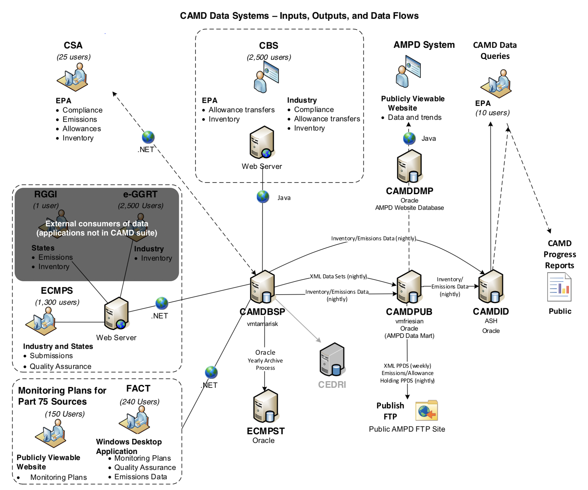

Within the above schema, the three key systems that are public and/or industry-facing are ECMPS, AMPD, and CBS. A further description of these systems and their functions are described below:
ECMPS is a desktop client tool developed in .NET. It was created for use by the regulated community for them to report data to EPA as required by the continuous emission monitoring, reporting, and recordkeeping regulations (40 CFR Part 75). Using ECMPS, industry representatives can import (from a data acquisition and handling system (DAHS)) or manually enter data to report to EPA, including (a) monitoring plans that specify details about the monitoring system and formulas used to calculate emissions; (b) results from mandatory quality assurance tests of monitoring systems; (c) hourly emission, energy input, and operation data; and (d) reports for other non-CAMD administered programs (e.g., MATS and the Regional Greenhouse Gas Initiative). The data are subjected to thousands of quality assurance checks by ECMPS before an industry representative can submit the data to EPA. After the industry representative reviews the feedback results from the data quality assurance checks, the representative can submit the data to EPA. The submitted data are maintained in a central database and become available to the public via other tools (e.g., AMPD). To learn more about ECMPS, including news posts, software documentation, reporting instructions, data quality assurance check specifications, and help/tutorials, please visit the ECMPS Support website (https://ecmps.camdsupport.com).
AMPD is a web-based data query tool developed in Java. It allows industry, state agency, and general public stakeholders to query data about facility attributes, emissions, and allowances. AMPD also includes prepackaged data commonly requested by users, such as emissions trends, top emitters, allowance account balances, allowance allocations, and more, accessible through a simple interface via any standard web browser. To interact directly with the tool and learn more, please visit the AMPD site (https://ampd.epa.gov/ampd).
CBS provides a central location for authorized industry representatives to review, submit, and update certain data related to the ARP and CSAPR programs, minimizing the need to submit paper forms. Depending on their role(s), representatives can perform important business functions, including:
- Identifying the Designated Representatives for a plant
- Assigning Agents to perform CBS/ECMPS functions on behalf of Representatives
- Managing facility and people information, including facility attributes, owners/operator, and contact information
- Managing allowance accounts, including transferring allowances, assessing compliance, and updating account information
To learn more, please visit the CAMD Business Center (https://www.epa.gov/airmarkets/business-center).

Purpose and Scope of the CAMD Suite

Product Vision
For the EPA, industry, state, and public, who need to comply with, enforce, or understand regulatory air programs and progress, the CAMD Suite will be an easily accessible, intuitive, and adaptable tool that cost effectively and securely collects and disseminates high quality data, empowering its users with transparent data to hold industry and government accountable.

Purpose
The purpose of this Statement of Objectives (SOO) is to provide information technology services to support the design, development, deployment, and maintenance of the updated CAMD Suite with a focus on the functions currently provided by ECMPS – supporting emission reporting – and AMPD – providing access to emission and allowance data. The information technology services under this Statement of Objectives includes activities such as consulting, architecture planning, design, code development and maintenance, testing, documentation, end-user support, Agile/Scrum coaching, and task order management. In general, updating the CAMD Suite will require:
- Designing intuitive and easy-to-use systems with the user in mind, continuously engaging end-users during product design and development (i.e., user-centric design) and adhering to accessibility requirements (i.e., Section 508 usability requirements and standards);
- Building reusable components to minimize ongoing maintenance costs and ensure consistency within and across applications;
- Utilizing rules engines, when appropriate, to apply business rules (e.g., electronic data quality assurance checks) consistently and to promote flexibility and reusability;
- Building secure systems that adheres to federal and EPA IT regulations and standards, and can run on EPA-approved web and/or cloud platforms;
- Developing and operating in a DevOps (or DevSecOps) environment;
- Integrating automated testing to ensure high quality, reliable software deployments;
- Applying best-practice Agile development and project management methods;
- Engaging EPA technical staff in a collaborative design and development process to ensure EPA’s ability to maintain and support the software in the future; and
- Using free and open source software and tools to build the system so that the final components can be offered in the public domain.

Scope

Backlog
Applying best-practice Agile/Scrum development methods includes managing a shared backlog for development and code maintenance. To provide an illustration of the type of user stories that may populate the backlog, several example user stories are provided. These user stories do not comprise the full scope or detail of the project, which will emerge over the course of the engagement through close collaboration between the contractor and EPA Product Owner(s) during regular user research and usability testing.
The actual user stories developed as part of the engagement may be modified, added to, retracted, and/or reprioritized by the EPA at any time. The EPA expects that the user stories will be continuously refined during the development process.
Illustrative User Stories
 | As a | I want to | So that I can
1 | DAHS vendor or emission monitoring staff at a facility | review and update a monitoring plan | review the monitoring system information to comply with required provisions and update system information
2 | Emission monitoring staff at a facility | evaluate my data against EPA Part 75 data quality requirements | QA my data before it is submitted to EPA pursuant to Part 75
3 | Emission monitoring staff at a facility | submit my EDRs (electronic data records) for monitoring plans, quality assurance test results, and/or emissions | stay compliant with EPA's emission reporting requirements in the Part 75 Rule (40 CFR Part 75)
4 | Emission monitoring staff at a facility | input and submit Low Mass Emission (LME) unit EDRs | submit LME emissions files without a DAHS and stay compliant with EPA's emission reporting requirements in the Part 75 Rule
5 | Emission monitoring staff at a facility | input and submit MATS compliance report EDR | submit MATS compliance reports without a DAHS and stay compliant with EPA’s reporting requirements in Part 63 Rule (40 CFR Part 63) (MATS)
5 | EPA or state agency staff | view previous data submitted to EPA | review data to assess data quality and/or compliance
6 | DAHS vendor, stack tester, or emission monitoring staff at a facility | view and interpret EPA electronic check evaluation feedback | troubleshoot and correct data quality issues prior to submission to EPA
7 | EPA staff | replicate error situations in EDR submissions | work with DAHS vendors, stack testers, and/or emission monitoring staff at a facility to fix errors
8 | EPA staff | review and modify electronic checks and error messages | review QA checks for links with underlying regulations and update error messages to improve clarity
9 | EPA and state agency staff | view a monitoring plan | prepare for an on-site audit of the monitoring system
10 | EPA and state agency staff | easily access system-generated electronic check feedback reports, notifications, and emails | provide good customer service
11 | an industry agent or representative | add and modify plant information | ensure that the correct representatives have permissions to make submissions
12 | an academic researcher | download facility and emission data | conduct academic analyses / research using emission and / or allowance data
13 | public | view information about power plant emissions | see how power plants near me compare to the national average
14 | State agency air quality modeler | view detailed hourly emission data, including data source and quality indicators | prepare data for use in modeling studies

List of Deliverables with Quality Assurance Surveillance Plan (QASP)
The following table sets forth the performance standards and quality levels the code and documentation provided by the contractor must meet, and the methods the EPA will use to assess the standard and quality levels of that code and documentation.
Quality Assurance Surveillance Plan (QASP) (This QASP is a sample only. It represents high levels project areas the government may choose to surveil). See the solicitation for further information and guidance.

Deliverable | Performance Standard(s) | Acceptable Quality Level | Method of Assessment | Frequency | Incentive or Disincentive
Tested code | Code delivered under the order must have substantial test code coverage.  Version-controlled, EPA-managed GitHub code repository that comprises product that will remain in the government domain. | Minimum of 90% test coverage of all code. All areas of code are meaningfully tested. | Combination of manual review and automated testing | At the end of each sprint and with final delivery (release). | TBD –contractor may be asked to provide suggested incentives or disincentives in its proposed solution.
Properly Styled Code | GSA 18F Front- End Guide | 0 linting errors and 0 warnings | Combination of manual review and automated testing | At the end of each sprint and with final delivery (release). | TBD –contractor may be asked to provide suggested incentives or disincentives in its proposed solution.
Accessible | Web Content Accessibility Guidelines 2.1 AA standards | 0 errors reported using an automated scanner and 0 errors reported in manual testing | https://github.com/pa11y/pa11y | At the end of each sprint and with final delivery (release). | TBD –contractor may be asked to provide suggested incentives or disincentives in its proposed solution.
Deployed | Code must successfully build and deploy into staging environment. | Successful build with a single command | Combination of manual review and automated testing | At the end of each sprint and with final delivery (release). | TBD –contractor may be asked to provide suggested incentives or disincentives in its proposed solution.
Documented | All dependencies are listed and the licenses are documented. Major functionality in the software/source code is documented. Individual methods are documented inline in a format that permits the use of tools such as JSDoc. System diagram is provided. | Combination of manual review and automated testing, if available | Manual review | At the end of each sprint and with final delivery (release). | TBD –contractor may be asked to provide suggested incentives or disincentives in its proposed solution.
Secure | OWASP Application Security Verification Standard 3.0 | Code submitted must be free of medium- and high-level static and dynamic security vulnerabilities | Clean tests from a static testing SaaS (such as Snyk or npm audit) and from OWASP ZAP, along with documentation explaining any false positives | At the end of each sprint and with final delivery (release). | TBD –contractor may be asked to provide suggested incentives or disincentives in its proposed solution.
Open source | Free and open source software and tools | contractor must obtain EPA written permission before delivering software incorporating any software or tools that is not free or open source | Manual review | At the end of each sprint and with final delivery (release). | TBD –contractor may be asked to provide suggested incentives or disincentives in its proposed solution.
User research | Usability testing and other user research methods must be conducted at regular intervals throughout the development process (not just at the beginning or end). | Research plans, user stories, and artifacts from usability testing and/or other research methods with end users are available at the end of every applicable sprint, in accordance with the contractor’s research plan. | EPA will manually evaluate the artifacts based on a research plan provided by the contractor at the end of the second sprint and every applicable sprint thereafter. | At the end of each sprint and with final delivery (release). | TBD –contractor may be asked to provide suggested incentives or disincentives in its proposed solution.

General Program Management
The contractor will work collaboratively with the EPA CAMD Suite team, including the Product Owner(s), user experience (UX) specialists, developers, and subject matter experts (SMEs), using best practices of Agile/Scrum development methods. This will include weekly meetings to develop, groom, and prioritize the backlog; discuss issues; and review progress. The contractor will also conduct periodic discussions (both formal and informal, telecom and face-to-face) with CAMDBS stakeholders in the form of technical exchange meetings (TEMS), collaborative development sessions, program reviews, design reviews, etc., as required.
To facilitate communication with the EPA CAMD Suite team, the contractor shall use the EPA-managed Microsoft Teams for real-time interactions and communication.
For the purposes of project management, issue tracking, collaboration, and transparency, the contractor shall use EPA-provided information platforms (e.g., Microsoft Teams, Atlassian tool suite) to track and display project documentation, milestones, user stories, defects, and tasks. Where EPA is unable to provide information platforms, the contractor shall provide them. The contractor shall enter and maintain the information in the information platform so that EPA CAMD Suite team members can generate regular reports and review user stories, defects, and tasks and their statuses. If EPA prescribes a specific EPA-managed software platform, the contractor shall facilitate the transition from the contractor-managed information platform to the EPA-managed platform.
To facilitate contract management, the contractor may elect to use a proprietary financial reporting tool and / or securely submit invoices and other necessary contract or proprietary financial information to EPA through email.
To ensure quality is managed through the lifecycle of the engagement, the contractor shall develop and maintain a quality management plan (QMP) or quality assurance project plan (QAPP). To identify potential risks and how to mitigate them, the contractor shall also develop and maintain a risk management plan (RMP).

Reporting
The contractor shall provide formal written monthly progress reports that include information about progress (using information drawn from the information platform described above) during the month, level of effort (LOE) expended during the month (if used), planned actions for the next month, projected LOE (if used) for the next month, and risks that may interfere with planned activities for the next one to six months. Contractor shall also provide monthly invoices and other financial reports required under the contract.
The contractor shall conduct a quarterly engagement update for EPA management and EPA CAMD Suite stakeholders. The purposes of the meeting are demonstrating progress; discussing plans, lessons learned, roadblocks or risks; and reviewing any skill gaps (in the contractor and / or EPA teams) and team member changes. The contractor shall post an agenda for the quarterly engagement update and post it to the EPA-managed Microsoft Teams or other platform specified by EPA.

Contract Place of Performance
The contractor may choose the location(s) from which to perform the required software development services. The contractor team must be available during the EPA’s core hours from 9:30am to 3:00pm Eastern time. Virtual interaction is acceptable and expected. Real-time interaction will be conducted through EPA-managed Microsoft Teams.

Operating Constraints (Non-functional Requirements)

Environment

Portability
Applications should be built for the web, using open web standards, not for specific browsers, client hardware, operating systems, or installed library/framework versions.
The current version of the CAMD Suite relies heavily on Oracle stored procedures, functions, and packages. To help ensure portability to other database systems, the contractor shall shift logic and computation into libraries at the web service and/or application layers.
Applications should be constructed in a manner suitable for deployment on modern cloud platforms and designed for Platform-as-a-Service portability.

Accessibility
Ensure Section 508 compliance across the CAMD Suite by building web-based solutions passing the WCAG (Web Content Accessibility Guidelines) 2.1 Level AA Success Criteria. Incorporate the United States Web Design System (USWDS) to help achieve this goal.

Usability
Applications within the CAMD suite should be designed with the primary user roles/personas in mind, what tasks they need to accomplish, and efficient ways to accomplish those goals.

Compliance
The areas of Code of Federal Regulations listed in section 1.0 Background dictate an initial set of compliance requirements for the CAMD Suite.
In addition:
- Ensure all subsystems of the CAMD Suite implement the required controls specified by the National Institute of Standards and Technology (NIST) Risk Management Framework (RMF), targeting FISMA Moderate.
- Build the CAMD Suite in alignment with the website modernization requirements of the 21st Century Integrated Digital Experience Act (H.R.5759).

Availability
Design and implement the CAMD Suite targeting a 99% uptime.

Flexibility
Task-specific reporting is a common theme across the CAMD Suite applications. An improved CAMD Suite should permit efficient creation of new reports and make it easy to expose them across multiple applications and to the public, using an API-first approach.

Integrity
Ensure that monitoring plans, quality assurance test data, inventory data, emissions data, account data, allowance data, etc. are maintained with well-defined audit records, preserving original data as well as revised data, and allow changes only by authorized users.

Scalability
To varying degrees across the CAMD Suite, usage can spike dramatically during reporting periods or compliance deadlines. For example, for the period of May to June 2019, CAMD received 1,347 files via ECMPS. In July, the 30-day window for end-of-quarter-reporting, CAMD received 8,739 files via ECMPS. Design and implement the CAMD Suite sub-systems so that underlying resources (computing, storage, etc.) can be dynamically allocated when usage dictates and dynamically deprovisioned when no longer in use.

Opportunistic reuse
The existing CAMD software employs on the order of 1 million source lines of code (SLOC) in SQL, and on the order of 1 million SLOC in C#, Java, and Groovy. This code base and supporting documentation/specifications are a valuable representation of very specialized CAMD domain knowledge and business processes. An updated CAMD Suite should be designed and built with the guidance of the EPA Product Owner(s) and SMEs, but also with the existing code base and documentation as a reference aid.
Further – and only as the update CAMD Suite’s technology stack, maintenance tradeoffs, and architecture suggest – encapsulate and reuse existing library code to minimize cost and risk of wholesale reimplementation.

Refer to www.section508.gov for more information about accessibility standards.
The EPA intends to publish the software in the public domain. As described in the Quality Assurance Surveillance Plan (QASP), the contractor will have to obtain EPA permission before delivering software that incorporates any software that is not free and open source. The contractor must post all developed code to an EPA-managed GitHub repository designated by the EPA.

